**Academic Plan, Step2-6 (Due 9/30/19)**

**Step 2: Complete the Survey**

Complete the file named “Step2-Academic Plan Assignment Survey” to the best of your knowledge. (You should be able to see this file on the assignment drop box).

* **Upload your completed file to this assignment’s drop box on Blackboard.**

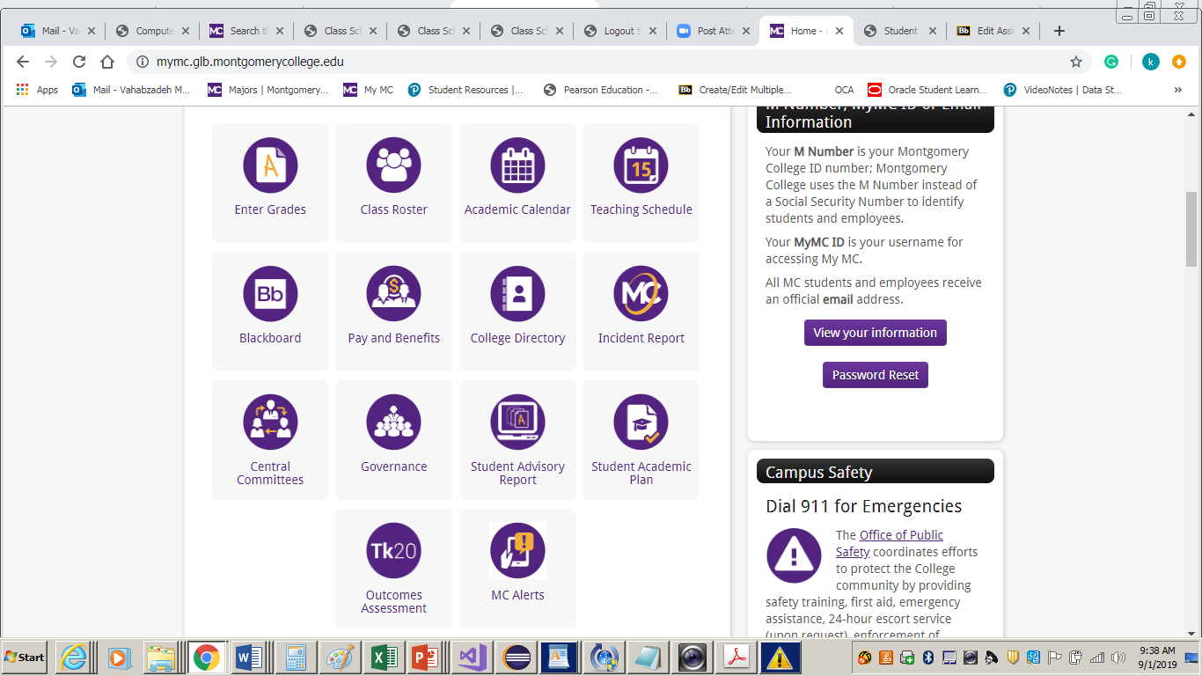 **Step 3: Fill out advising sheet for declared major or student advising guide**

a) Open Student Academic Report (SAR) by login to MyMC and clicking on

b) Locate your program requirements in the MC Catalog:

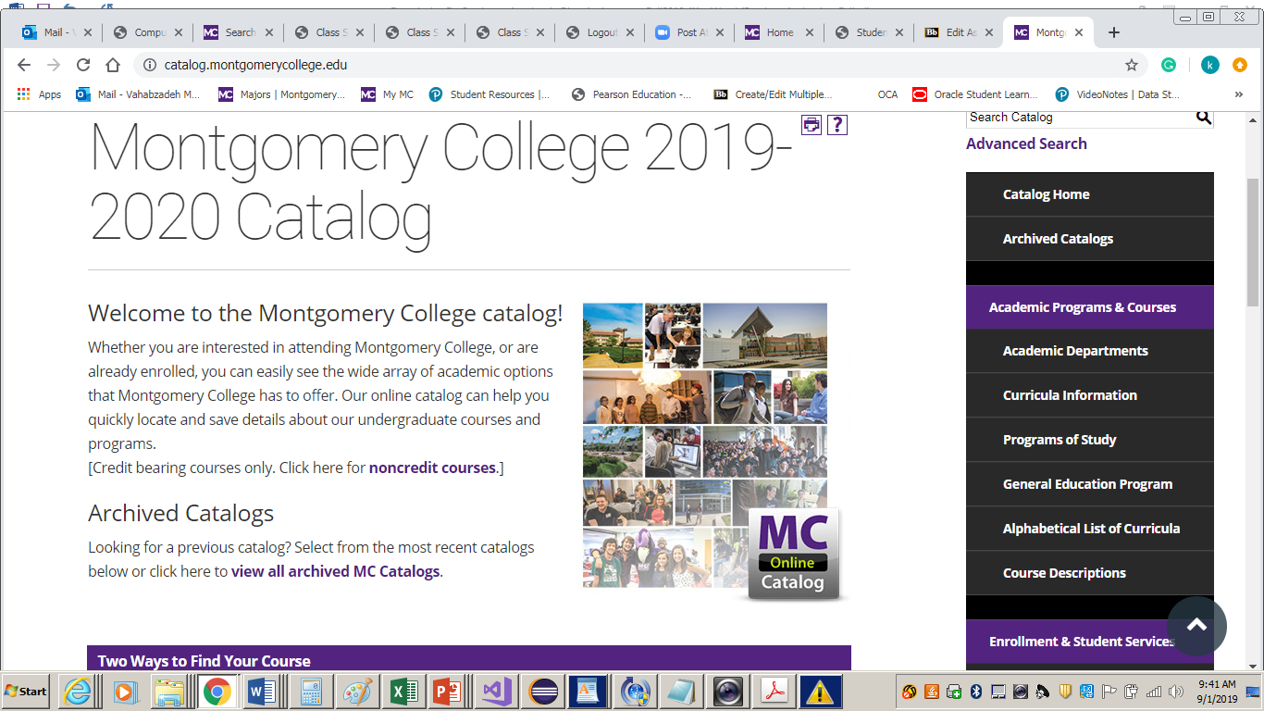

1. Go to <http://catalog.montgomerycollege.edu/>

then select the **Program of study** link.

1. Select your program and scroll down to section named “**Program Outline / Degree Requirements**”. This page contains the information required for your degree/certificate. Review the information on this page and refer to it for completing your Program Advising sheet/Advising guide.
2. Open another browser window and locate your program Advising sheet (or advising guide in pdf format) from this link.

<http://cms.montgomerycollege.edu/EDU/plain.aspx?id=15000>

OR

(<https://www.montgomerycollege.edu/academics/program-advising/advising-guides.html>)

Fill out the **Grade** column for all the courses you have taken so far in the Program Advising Guide (Sheet) or Advising Worksheet by referring to your “Student Academic Report” (**SAR**, Step 3 a ). For courses taken in the fall 2019, put **F19** (in the Grade column), for courses planning to take in the future semesters put the semester name and year. For example **sp20** for spring of 2020 and etc.

* + - **Upload your completed Advising sheet to this assignment’s drop box on Blackboard.**

**Step 4: Fill out semester based Word document**

Fill out Semester-based Word document named “**Step4_SemesterBasedPlanFall019**” for the current semester and future semesters. (You should be able to see this file in the assignment’s drop box). If you are graduating this semester then you only need to fill out one semester and put a note: *graduating this semester.*

* **Upload your completed document to this assignment’s drop box on Blackboard.**

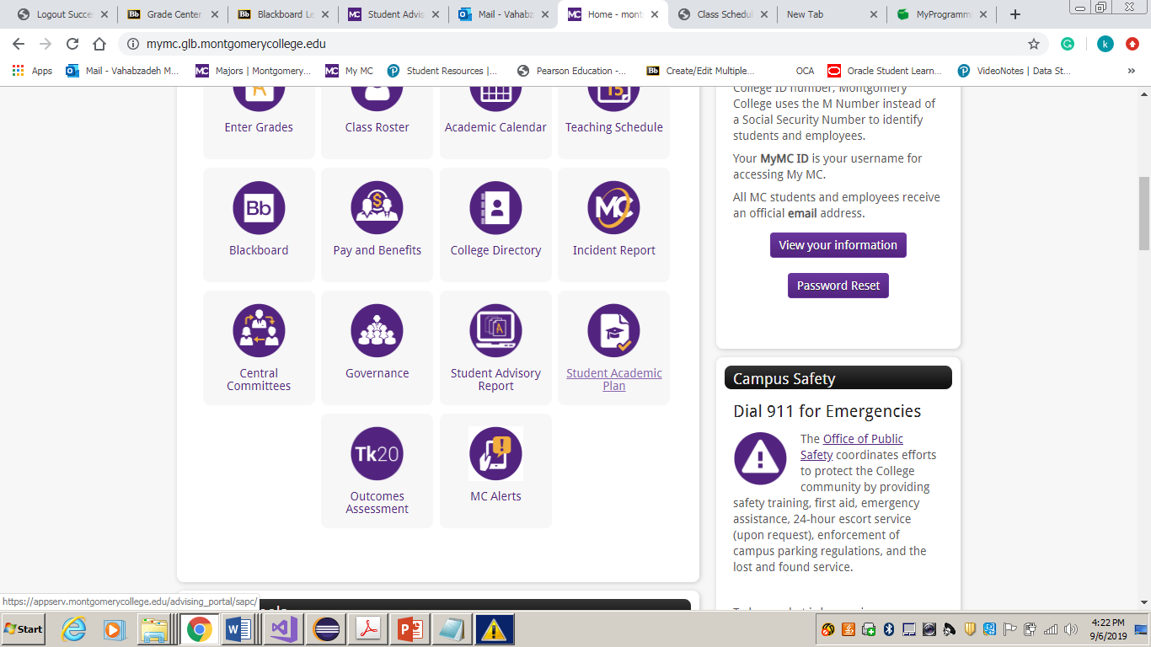**Step 5: Fill out SAPC based on the Word document**

Create/Update the Student Academic Plan (SAPC) located on the home

page of MyMC based on the Semester-based Word document that you

completed in the previous step.

* **Take a screenshot of the completed SAPC plan and Notes section and submit these screenshots to this assignment’s drop box on Blackboard.**

**Step 6: Meet with the Advisor**

Meet with Program Academic Advisor to review your SAPC.

Ask Academic Advisor to add Notes in the Step 2 “*Advisor Information*” Section of SAPC to indicate when plan was reviewed.